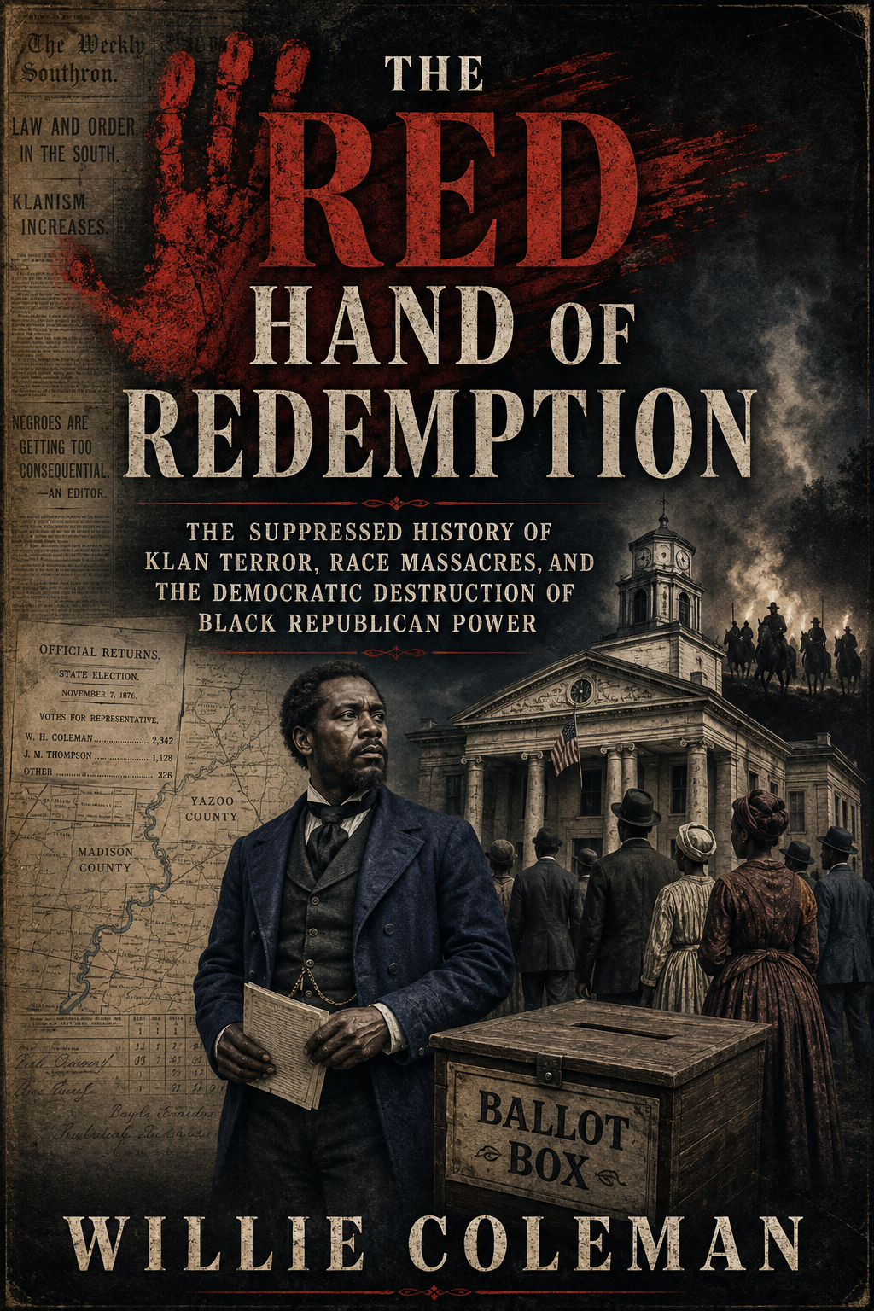

THE RED HAND OF REDEMPTION

The Suppressed History of Klan Terror, Race Massacres, and the Democratic Destruction of Black Republican Power

WILLIE COLEMAN
Author’s Research Edition
August 2026

Copyright © 2026 Willie Coleman. All rights reserved.
This research edition is a documented historical work. “Democratic,” “Republican,” and other political labels identify organizations, coalitions, candidates, or officials at the time of the event under discussion. Estimates of deaths are presented as ranges where the historical record is incomplete. Organizational responsibility is stated only at the level supported by the evidence.
Dedication
To the Black citizens who went to the ballot box knowing the road home might be watched; to the officeholders whose names were pushed out of the public record; and to the families who remembered what official histories tried to forget.

Contents
Preface: The History Beneath the Label 5
Introduction: Reconstruction Did Not Simply Fail 7
Part I — Freedom Meets Counterrevolution 10
1. Black Republican Power Becomes Real 11
2. The Ballot and the Bullet, 1868 13
3. The Invisible Government 15
4. Congress Hears the Survivors 17
Part II — From Hoods to Uniforms 19
5. Colfax: Massacre and Constitutional Retreat 20
6. The White League Makes the Counterrevolution Public 22
7. The Mississippi Plan and the Red Shirt Campaign 24
Part III — Redemption Becomes Government 26
8. From Massacre to Disfranchisement 27
9. The Second Klan and the One-Party South 29
10. Bombingham and Mississippi Burning 31
Part IV — How the Record Was Suppressed 33
11. The Vocabulary of Innocence 34
12. What Redemption Destroyed 37
Epilogue: The Ballot Box Still Stands 39
Appendix A — Evidence and Attribution Code 40
Appendix B — National Incident Ledger 42
Appendix C — Primary-Source Research Map 44
Appendix D — Black Political Power Research Roster 45
Notes 46
Selected Bibliography 47
About the Author 49

Preface: The History Beneath the Label
The familiar picture of Reconstruction is a picture of disorder: corrupt governments, inexperienced voters, disputed elections, and a tired nation finally turning toward “home rule.” That picture was not accidental. It was produced by the political victors of Reconstruction’s counterrevolution and repeated by monuments, newspapers, textbooks, films, and professional historians. In that version, white armed organizations appeared as a regrettable response to Republican excess. Black citizenship appeared as an experiment imposed from outside. Democratic “Redemption” appeared as the restoration of legitimate government.
The record tells a harder story. After slavery ended, Black Southerners built churches, schools, mutual-aid societies, conventions, militia companies, labor organizations, and Republican political institutions. They registered and voted in extraordinary numbers. They served as registrars, sheriffs, justices of the peace, county commissioners, legislators, constitutional delegates, and members of Congress. Eric Foner’s Freedom’s Lawmakers documents more than two thousand Black officeholders during Reconstruction, while Charles Vincent’s study of Louisiana reveals a political world that older narratives routinely reduced to caricature.
That political world did not simply fade. It was attacked. The first Ku Klux Klan and related secret organizations beat voters, murdered organizers, drove teachers from communities, burned schools, threatened election managers, and forced Republican officials from office. When federal enforcement damaged the hooded Klan, the same counterrevolution became more open. White Leagues, rifle clubs, Red Shirts, Young Men’s Democratic Clubs, sheriffs’ posses, and armed campaign organizations performed comparable work under different names. Their common target was not Black life in the abstract. It was Black citizenship made concrete through ballots, public office, land, wages, education, jury service, and self-defense.
The U.S. House Historian summarizes the result directly: Southern Democrats orchestrated terror to disenfranchise Black voters and roll back Reconstruction. Foner describes the first Klan as a military force serving Democratic interests. Those conclusions are not partisan slogans added to the past. They arise from the testimony of victims, congressional investigations, military reports, election returns, court proceedings, newspapers, and the stated objectives of the organizations themselves.
Yet accuracy requires more than reversing an old myth. Not every white mob was the Klan. Not every massacre was ordered by a Democratic committee. The White League was not the Klan; the Red Shirts were not the Klan; the Wilmington coup was not a secret Klan operation. In some cases the Democratic tie is direct and organizational. In others it lies in local official participation, political protection, or the electoral benefit of violence. In several famous massacres, neither Klan command nor party direction has been proved. Precision does not weaken the case. It reveals the larger machinery.
This book therefore follows an evidence rule: name the organization actually present; identify party affiliation at the time; distinguish orders from approval, participation, protection, and benefit; preserve disputed casualty ranges; and record counterevidence. The goal is not to assign inherited guilt to living voters. The goal is to recover responsibility that belonged to named historical institutions and actors—and to show what their victory cost the United States.

Introduction: Reconstruction Did Not Simply Fail
The phrase “Reconstruction failed” sounds almost natural. It places the period beside an abandoned building project: ambitious, poorly designed, and finally left unfinished. But failure is too passive a word for courthouse assaults, night raids, political assassinations, election massacres, coups, and constitutional disfranchisement. Reconstruction was contested, compromised, and abandoned by federal power, but across much of the South its democratic institutions were also deliberately overthrown.
The sequence matters. Congress established new constitutional rules through the Thirteenth, Fourteenth, and Fifteenth Amendments. Republican state governments expanded public education, civil rights, and access to political participation. Black voters provided essential Republican majorities in numerous counties and districts. Black officeholding made emancipation visible in the courthouse and legislature. White counterrevolutionaries then attacked precisely those locations and people: party meetings, polling places, officeholders, militia units, schoolhouses, newspapers, and county seats.
The first Klan emerged in Pulaski, Tennessee, in 1865 or 1866 as a social fraternity of former Confederates and rapidly became a decentralized system of political terror. Its local dens did not require a transparent national chain of command to produce a common result. They shared enemies, costumes, rituals, warnings, and methods. They punished Black political participation and white Republican cooperation. They were strongest where Republican votes and institutions threatened established white authority and often absent where that threat did not exist.
The political connection can be measured in several ways. First is direct membership: Klansmen who also led Democratic clubs, campaigns, or local government. Second is functional coordination: violence timed to registration, elections, contested offices, or Republican meetings. Third is public legitimation: Democratic newspapers and speakers portraying victims as radicals, criminals, or agents of “Negro rule.” Fourth is protection: sheriffs, prosecutors, juries, and governors who failed to act, acted selectively, or treated Black self-defense as the primary crime. Fifth is electoral effect: collapsed turnout, Republican flight, forced resignation, and Democratic takeover.
This book codes that connection from D3 to D0. D3 means a direct or functional Democratic tie: a Democratic campaign force, leaders acting for a Democratic electoral objective, or overwhelming scholarly and primary-source evidence of that role. D2 means a strong alliance without a complete command chain. D1 means individual official complicity or a Democratic governmental context without proof of party direction. D0 means no adequate party link has been established. Klan responsibility is separately coded K3 through K0, from confirmed organizational responsibility to a different force entirely.
This distinction is essential because “the Klan” can become a fog. If every white terrorist is called a Klansman, the public White League vanishes. If every massacre is called a Klan massacre, the Democratic coup leaders of Wilmington disappear behind hoods they did not need. If every Democratic official is treated as a conspirator, the argument outruns the evidence and overlooks officials who opposed violence. The suppressed fact is larger than a single organization: the movement called Redemption used changing instruments to destroy biracial Republican government.
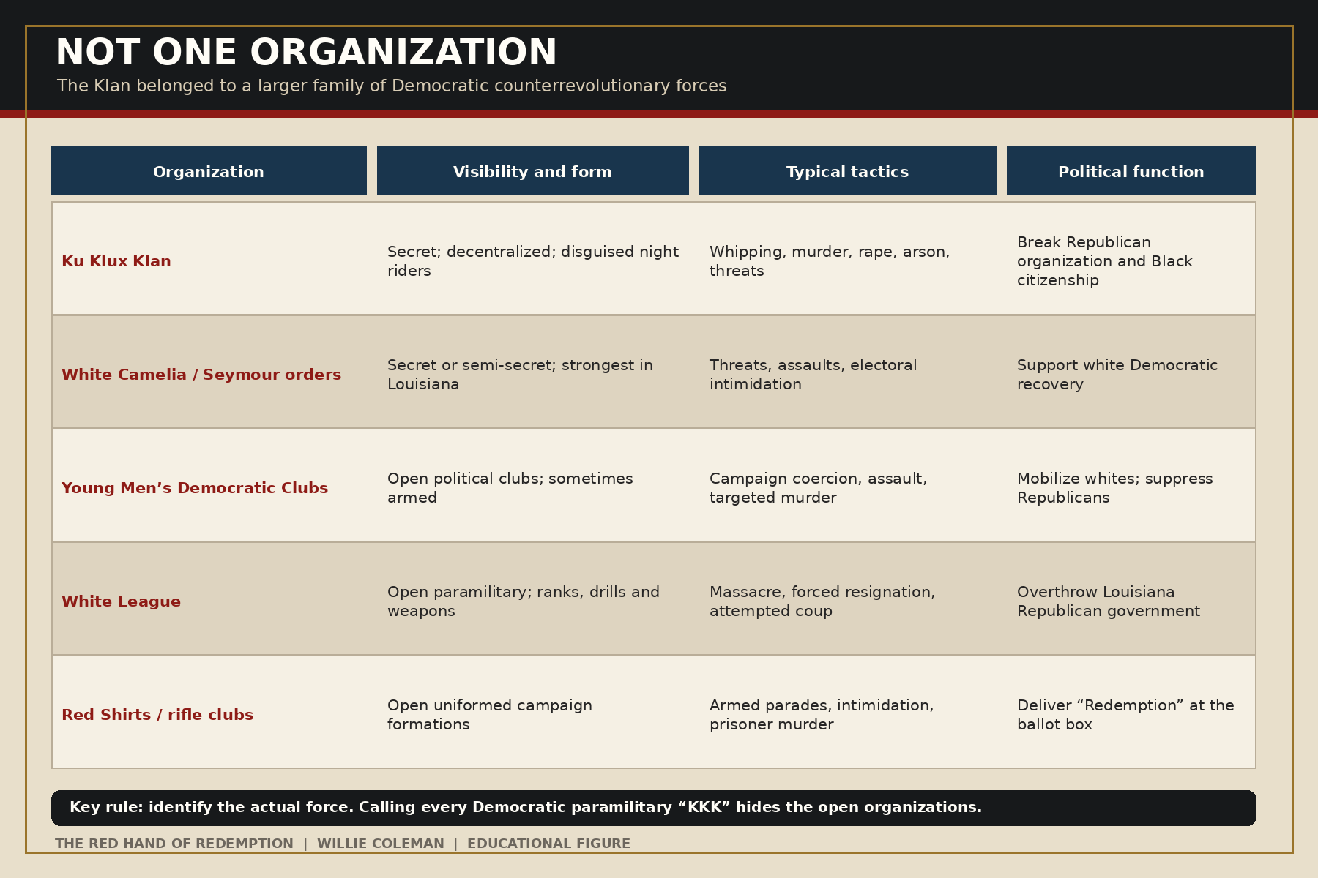
Figure 1. The Klan and the larger family of Democratic counterrevolutionary organizations.

The thesis
The central thesis is straightforward. During Reconstruction, the first Ku Klux Klan functioned as the underground military arm of the movement to restore Southern Democratic rule. Federal suppression of the Klan did not end the political project. Open Democratic-aligned paramilitaries, violent campaign organizations, and sympathetic or captured public institutions carried it forward. Massacres and assassinations altered elections, emptied offices, broke communities, and prepared the way for legal disfranchisement. Later generations then renamed this counterrevolution “home rule,” “race riot,” or the natural end of a failed experiment.
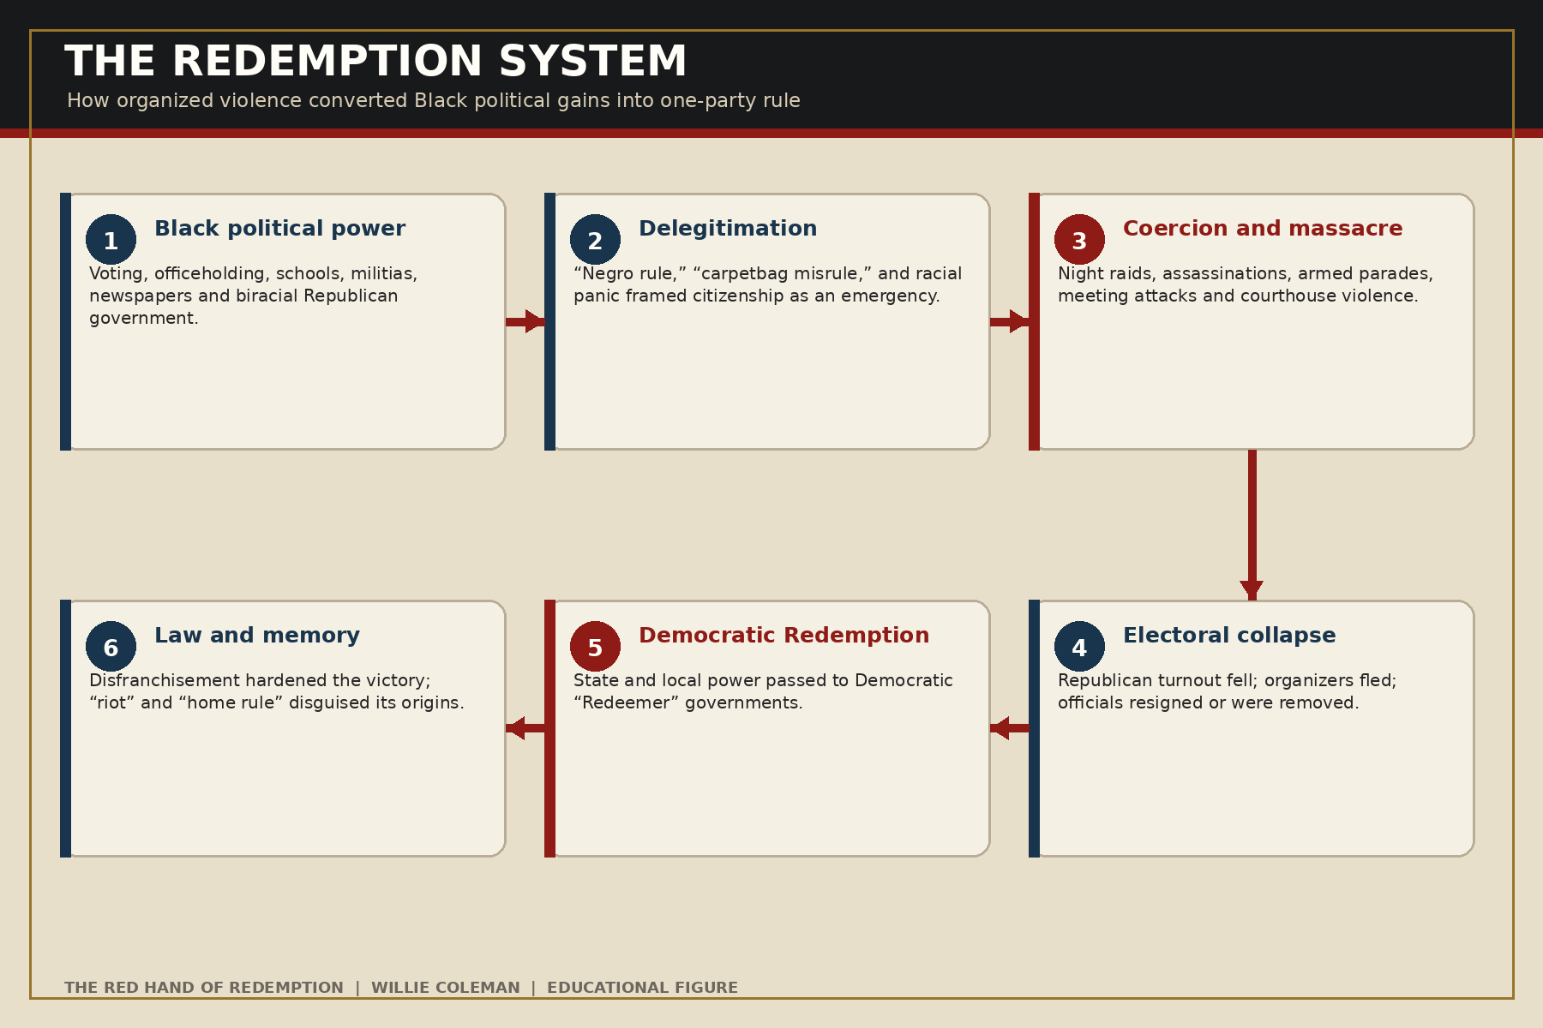
Figure 2. The Redemption system: how political violence converted Black political gains into one-party rule.

The people at the center
The book is not mainly about robes, insignia, or notorious white leaders. It is about the citizens those organizations feared. Joseph Rainey of South Carolina, the first Black person to serve in the U.S. House of Representatives, demanded federal protection against Klan terror. On the House floor he rejected constitutional theory that could not protect actual citizens: “Tell me nothing of a constitution which fails to shelter beneath its rightful power the people of a country!”
Rainey’s argument defines the moral question running through every chapter. A right that exists on paper but cannot be exercised at a polling place, courthouse, school, or home is a promise without protection. Reconstruction’s opponents understood that. They did not need to repeal the Fifteenth Amendment if a voter could be whipped, fired, evicted, or killed for using it. They did not need to prohibit Black officeholding if officeholders could be driven out. Violence was not merely an expression of hatred. It was government by unofficial means.

Part I — Freedom Meets Counterrevolution

1. Black Republican Power Becomes Real
Emancipation did not leave four million freed people waiting passively for national politicians to define freedom. Black Southerners moved to reunite families, legalize marriages, negotiate labor, establish independent churches, acquire land, build schools, and demand equal treatment before the law. Political organization grew from these community structures. Union Leagues and Republican clubs taught constitutional rights, registered voters, selected candidates, and connected local demands to state and national power.
The Republican Party of Reconstruction was a coalition rather than a single social bloc. It included formerly enslaved and freeborn Black citizens, white Southern Unionists, Northern migrants, veterans, teachers, entrepreneurs, and federal officials. Their motives differed. Some believed deeply in equal citizenship; others sought office, contracts, or economic development. But the coalition’s existence made a revolutionary fact possible: Black men participated as voters and lawmakers in states that had recently treated them as property.
Foner’s officeholder research and Vincent’s Louisiana study expose how much was built. Black lawmakers did not merely occupy symbolic seats. They debated taxation, public schools, labor relations, transportation, civil rights, and government administration. Louisiana elected Oscar J. Dunn lieutenant governor in 1868. P. B. S. Pinchback briefly served as governor. Black legislators and local officers represented parishes where the Black electorate was decisive. Across the region, Joseph Rainey, Robert Brown Elliott, Robert Smalls, Hiram Revels, Blanche K. Bruce, and others carried Reconstruction into Congress.
That achievement produced a specific counterrevolutionary fear. White supremacists had long used violence to control labor and movement. Now violence acquired an additional purpose: disabling a political coalition. A schoolteacher might be attacked because education supported independence. A minister might be attacked because the church hosted a Republican meeting. A farmer might be attacked because he served as an election manager. A Black militia member might be attacked because armed citizenship limited the power of white night riders.
The former Confederate political class reorganized inside the Democratic Party. The party’s 1868 national campaign circulated explicitly white-supremacist appeals, while Southern Democratic rhetoric portrayed Reconstruction governments as illegitimate “Negro domination.” That language converted ordinary democratic participation into an alleged emergency. Once Black voting was defined as tyranny, violence against Black voters could be sold as liberation.

Memphis and New Orleans: violence before the mature Klan
The massacres in Memphis and New Orleans in 1866 show why the history cannot begin and end with the Klan. In Memphis, white police, firefighters, and civilians attacked Black residents and Union veterans. Forty-six Black people and two white people were killed; homes, churches, and schools were burned. A congressional investigation revealed the central role of public officers and the vulnerability of freedpeople where local government was hostile.
In New Orleans, former Confederates, armed white opponents, and municipal police attacked a reconvened constitutional convention and its supporters on July 30, 1866. The convention sought to revise Louisiana’s constitution and advance Black suffrage. The attackers killed dozens, overwhelmingly Black citizens and white convention supporters. The political connection was direct: Democratic municipal power attacked a Republican constitutional project. The Klan had not yet developed into a region-wide organization. Calling the massacre “Klan violence” would conceal the more immediate fact that uniformed and publicly empowered men carried out the assault.
The federal reaction to Memphis and New Orleans helped strengthen support for Congressional Reconstruction. The massacres demonstrated that presidential restoration without enforceable civil and political protection allowed former Confederate power to return through local institutions. They also established a recurring pattern: Black political assembly was characterized as disorder; white attack was characterized as restoration of order; and federal intervention was attacked as tyranny.

2. The Ballot and the Bullet, 1868
The elections of 1868 made the conflict unmistakable. New state constitutions, Black registration, Republican campaigns, and the presidential contest placed the future of Reconstruction before voters. White supremacists recognized that they could not reliably regain power through persuasion alone. Across several states, intimidation and mass violence narrowed the electorate.

Camilla, Georgia
On September 19, 1868, Black and white Republicans traveled toward Camilla for a political rally. Local officials and armed white residents warned them not to enter with music or weapons. The confrontation became an attack in which Black marchers were pursued beyond the town. Roughly nine to fifteen Black people were killed and many more wounded, though the precise number remains disputed. The event is often called the Camilla riot, but the political geometry is clearer than that label: an armed local force blocked a Republican meeting during an election season and attacked its largely Black participants.
The Democratic political objective is well documented; formal Klan command is not. Camilla therefore receives a D3/K1 rating in this book. That combination matters. It prevents the absence of a proven Klan order from being used to erase the party purpose, and it prevents party purpose from being used to invent a Klan chain of command.

Opelousas, Louisiana
The Opelousas massacre began with a dispute involving Emerson Bentley, a white Republican teacher and editor who published criticism of local Democrats. Bentley was assaulted. Rumors of his death and armed mobilization followed. White Democrats and allied secret organizations then conducted a sweeping campaign against Black Republicans in St. Landry Parish. Modern Louisiana scholarship places the number of Black dead above two hundred, while contemporary and later estimates vary widely.
The massacre’s electoral effect is among its clearest facts. Republican organization in the parish was broken. Black citizens were terrorized from the polls. Although Republican Ulysses S. Grant won Louisiana, he received no recorded votes in St. Landry Parish. The violence did not simply accompany an election. It changed who could participate in it.
The organizational labels are complicated. Sources refer to the Knights of the White Camelia, Seymour Knights, local Democratic clubs, and the Klan. Membership and methods overlapped. The most responsible conclusion is not that every attacker carried one confirmed membership card. It is that armed white Democrats and allied secret orders destroyed a local Republican electorate for a Democratic political result. The case is D3; the Klan connection is K2 rather than K3.

What the zero in the returns meant
An election return can look peaceful because it contains numbers instead of bodies. In a terrorized parish, however, a zero may record the success of threats, murder, forced flight, destroyed newspapers, and closed meetings. This is one reason massacre history must be connected to turnout data. The political effect of terror is visible not only in casualty lists but in sudden changes in registration, vote totals, officeholding, and party organization.
Opelousas teaches another lesson. Violence could be geographically selective. A party did not need to terrorize every Black voter in a state. It could target pivotal counties, visible organizers, or communities whose punishment would travel by rumor. Every survivor became a messenger. The ballot was formally secret, but the decision to approach the polls was public.
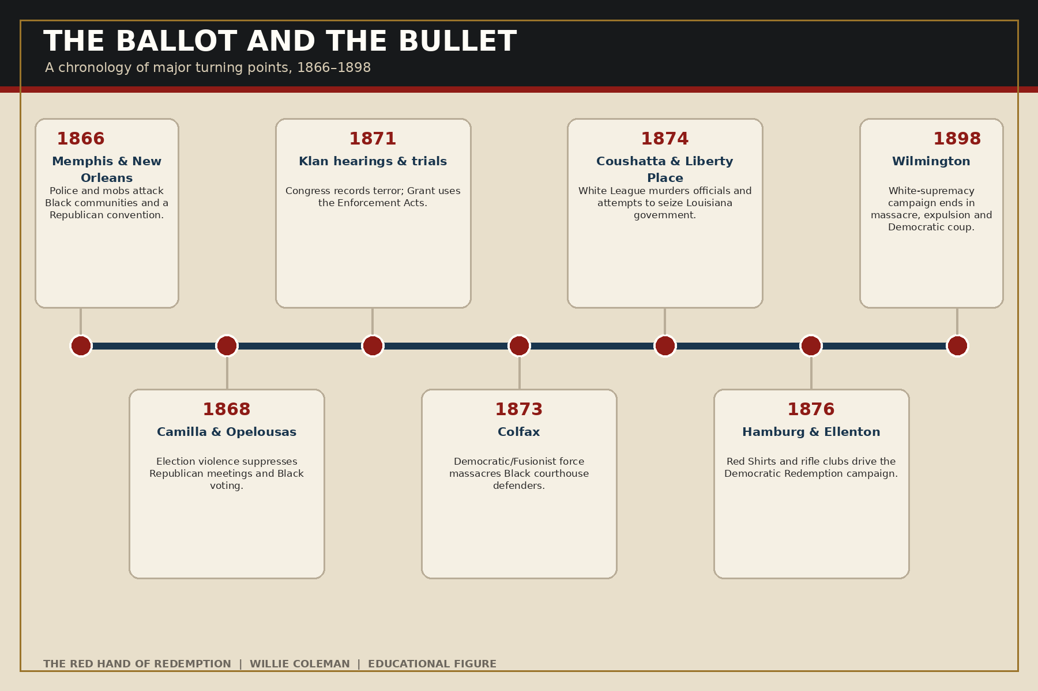
Figure 3. Major turning points from municipal violence to the Wilmington coup, 1866–1898.

3. The Invisible Government
The Reconstruction Klan was not a conventional army. It did not hold territory in continuous formations, publish ordinary rosters, or accept public responsibility for operations. Its strength came from local knowledge and deniability. Night riders knew who had registered, who taught school, who served in the militia, whose house hosted meetings, and which white citizens cooperated with Republicans. Masks hid individual faces while displaying collective power.
Congressional testimony documented repeated methods: men taken from homes at night; whippings severe enough to scar or disable; sexual violence; shootings; hangings; arson; warnings to leave a county; and forced promises to abandon Republican activity. The violence often combined political and economic discipline. A victim might be punished for voting, asserting a labor claim, buying land, educating children, carrying a weapon, or refusing deference.
The testimony of Black Republican legislator Abram Colby became one of the best-known records. Colby told Congress that armed men seized and brutally whipped him. His political loyalty was central to the attack; he refused pressure to abandon the Republican Party. His testimony matters not because his suffering was unique, but because he survived, held office, and entered the details into a federal record created in a period when local justice was often unavailable.

Jackson County, Florida
The Jackson County War of 1869–1871 demonstrates how serial assassination could function as county-level regime change. Historian Daniel R. Weinfeld reconstructs a campaign in which local Klan networks, former Confederate power, and Young Men’s Democratic Clubs attacked Black leaders, white Republicans, teachers, officials, and economic allies. Roughly one hundred people were killed in the sustained conflict, with some estimates higher.
The victims were not random. The removal of a sheriff, registrar, commissioner, teacher, merchant, or organizer damaged a network. Kill enough people, force enough resignations, and drive enough families away, and a political party can cease to exist without a statute outlawing it. Jackson County therefore belongs among the strongest D3/K3 examples: confirmed Klan terror and explicitly Democratic organizations operated toward the eradication of Republican power.

Eutaw, Laurens, and Union County
In Eutaw, Alabama, Klan gunmen attacked a Republican rally in October 1870, killing at least four Black citizens and wounding many. The terror helped suppress Black turnout and contributed to Democratic electoral success. In Laurens County, South Carolina, violence followed the 1870 election and struck Black Republican leadership. In Union County, Klansmen raided the jail twice in 1871 and murdered twelve Black prisoners.
The Library of Congress preserves an 1872 synopsis of the congressional investigation describing murders, whippings, burned schools, threats against election managers, and orders that Republican officials leave their counties. Even a Democratic-associated gubernatorial candidate called as a witness acknowledged an armed secret organization operating with regularity and method, and that attacks generally fell on Republicans.
This is the documentary heart of the “strong arm” thesis. The link does not depend on a later commentator noticing that Democrats benefited. The victims were questioned about political activity. Election managers were attacked as election managers. Republicans were ordered to resign or depart. Violence surged where Republican strength existed. The Klan’s targets identified its political function.

4. Congress Hears the Survivors
The federal government did not learn about Klan violence only through rumor. Congress assembled one of the largest bodies of testimony on domestic political terror in American history. The Joint Select Committee to Inquire into the Condition of Affairs in the Late Insurrectionary States gathered thirteen volumes of evidence from victims, witnesses, officials, physicians, defendants, and political leaders.
The record is imperfect. Witnesses testified under fear. Some minimized violence, protected neighbors, exaggerated partisan claims, or repeated uncertain information. Committee members themselves approached the investigation with political interests. Yet the breadth and repetition of the evidence are overwhelming. Across counties and states, witnesses described the same architecture: disguise, night raids, interrogation about political activity, demands to leave office or change allegiance, punishment for education and militia service, local official weakness or complicity, and community silence.
Black witnesses transformed private suffering into national evidence. Kidada E. Williams argues that survivor testimony created a vernacular archive of racial violence—an account produced by people whose bodies, homes, and families carried the marks of terror. Their words contest a later tradition that treated white-authored newspapers and court records as neutral while dismissing Black memory as partisan.

The Enforcement Acts
Congress responded with the Enforcement Acts of 1870 and 1871, including the law commonly called the Ku Klux Klan Act. The legislation protected federal voting rights, criminalized conspiracies to interfere with constitutional rights, expanded federal jurisdiction, and authorized the president to use extraordinary powers in areas where ordinary law had collapsed. Republican President Ulysses S. Grant signed the 1871 act and used it against the Klan in South Carolina.
Black Republican members of Congress were central defenders of federal action. Joseph Rainey argued that a Constitution unable to protect the humblest citizen was empty. Robert Brown Elliott, Robert De Large, and others described the choice before Congress: either national citizenship carried enforceable protection or local terror could nullify it. Democratic opponents often framed the act as unconstitutional centralization and a violation of state authority.
Federal prosecutions in South Carolina damaged Klan operations. The Federal Judicial Center’s account of the 1871–1872 trials shows both the capacity and limitations of enforcement: federal courts could break organized conspiracies when executive commitment, troops, investigators, prosecutors, and witnesses aligned. But enforcement was expensive, politically contested, and dependent on national will. Terror organizations adapted. Open paramilitary forces replaced secrecy. Northern voters and leaders grew less willing to sustain intervention.
The law left an enduring legacy. Section 1 of the 1871 act became 42 U.S.C. §1983, a foundational civil-rights remedy against state officials who violate federal rights. The statute’s origin is a reminder that private terror and public authority were intertwined. Congress was responding not only to masked criminals but to states unwilling or unable to protect citizens from them.

Part II — From Hoods to Uniforms

5. Colfax: Massacre and Constitutional Retreat
Louisiana’s disputed 1872 election produced rival claims to state and local offices. In Grant Parish, Black Republicans gathered at the courthouse in Colfax to defend officials recognized by the Republican state government. A white force led by Christopher Columbus Nash, associated with Democratic or Fusionist claimants, organized to take the courthouse.
On Easter Sunday, April 13, 1873, the white force attacked. The courthouse was set on fire. Black defenders attempted to surrender. Many were killed after resistance had ended. Three white attackers died; estimates of Black deaths range from at least sixty to well above one hundred. The missing and unrecorded make a false exact total impossible.
Colfax is often presented as a racial clash. That description removes the office dispute, the courthouse, the rival governments, and the selection of victims after surrender. It was an armed contest over whether Black Republican local government could exist. The Democratic/Fusionist political connection is direct. The formal Klan connection is less secure; some participants were described as Klansmen, but Nash’s force should not be converted into a proven Klan unit without further evidence. The book therefore rates Colfax D3/K2.

United States v. Cruikshank
Federal prosecutors used the Enforcement Acts to charge participants. The resulting case, United States v. Cruikshank, reached the Supreme Court. In 1876 the Court invalidated key convictions and adopted a narrow view of federal power over private interference with rights. The decision did not approve massacre, but it made federal protection against private racial terror substantially harder.
The legal aftermath completed what the attack began. Armed men destroyed the defenders at the courthouse; constitutional doctrine narrowed the reach of the government that attempted to prosecute them. Colfax thus stands at the intersection of massacre and state formation. Impunity was not merely the absence of punishment. It was a political resource. It told future armed organizations that local control, friendly juries, and restrictive federal doctrine could make terror effective.
The old Colfax historical marker once called the event a “riot” and celebrated it as the end of “carpetbag misrule.” That wording performed a second act of violence against the record. The attackers became restorers; the murdered defenders became the disorder; the political objective became legitimate government. Correcting the marker is not a cosmetic exercise. Public language determines which side appears to have defended democracy.

6. The White League Makes the Counterrevolution Public
Federal action made the Klan’s secrecy more costly, but it did not remove the desire to overthrow Republican government. In Louisiana, the White League emerged in 1874 as an openly armed political movement. Its units drilled, carried military weapons, adopted ranks, issued public statements, and coordinated with Democratic-Conservative politics. The disguise was being discarded because the movement expected public legitimacy.
Louisiana historical scholarship traces the White League to Democratic clubs and describes the overlap in membership as exceptionally close. The organization’s purpose was not hidden behind generalized racial hatred. It sought the removal of Republican officeholders and control of the state. This makes the White League one of the clearest examples of a Democratic paramilitary force that should not be mislabeled as the Klan.

Coushatta
In Red River Parish, White Leaguers forced six white Republican officeholders to resign and leave under a promise of safety. The prisoners were intercepted and murdered. Black witnesses and supporters were also killed. The Coushatta massacre communicated that formal office and negotiated surrender offered no protection where armed “Redeemers” controlled the roads.
The racial and political dimensions cannot be separated. White Republican officials were murdered because they participated in a biracial government dependent on Black voters. Black citizens were murdered because their votes, testimony, and armed presence sustained that government. White supremacy was the social order; Democratic takeover was the political mechanism.

Liberty Place
On September 14, 1874, the Crescent City White League confronted New Orleans’s Metropolitan Police and state militia. The attackers temporarily seized key government sites and forced Republican Governor William Pitt Kellogg from immediate control. Federal troops ultimately restored the government, but more than thirty combatants and bystanders died.
Later commemoration celebrated the White League as citizens who overthrew “usurping” rule. This memory transformed an attempted coup into civic heroism. The Liberty Place monument and the controversy surrounding it reveal how Redemption continued to govern public space long after the gunfire ended.
The White League’s importance extends beyond Louisiana. It shows that the historical case does not depend on proving that Democratic officials secretly ordered masked Klansmen. Here the organization was open, the political objective public, and the attempted change of government unmistakable. The movement’s red hand was visible.
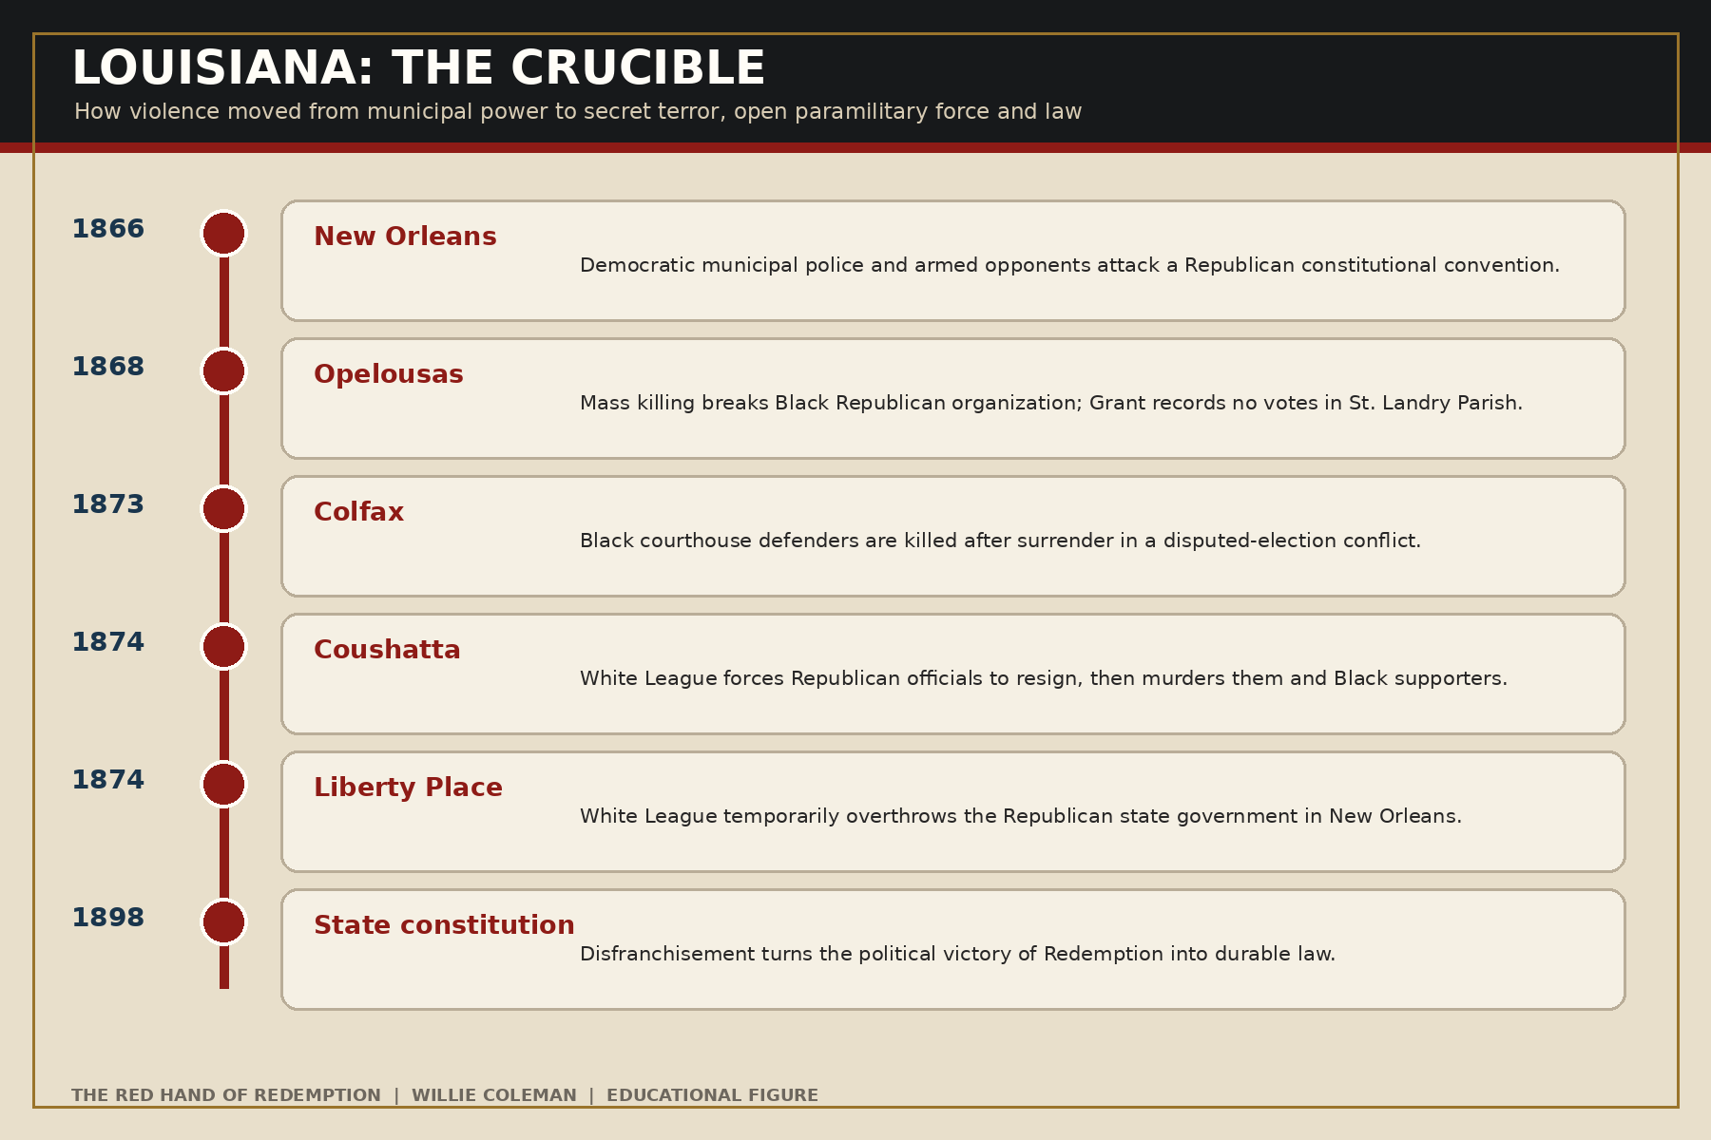
Figure 4. Louisiana’s sequence from the New Orleans massacre to disfranchisement.

7. The Mississippi Plan and the Red Shirt Campaign
By the middle of the 1870s, white Democrats increasingly combined armed intimidation with claims of normal electoral politics. The Mississippi Plan of 1875 used rifle clubs, economic pressure, disruption of Republican meetings, selective assassination, and overwhelming displays of armed force. The goal was to suppress enough Republican votes to capture the state while preserving an election-shaped result.
In Vicksburg in 1874, armed white forces moved against Black Republican county power, producing a massacre whose death estimates vary from dozens to more than one hundred. At Clinton in 1875, election-season violence killed an uncertain number of Black citizens, commonly estimated in the dozens. These cases require continued archival work on casualty totals and individual chains of command, but their political placement inside the campaign for Democratic restoration is strong.
The technique was scalable. Employers could threaten workers. Landlords and merchants could threaten tenants and customers. Armed clubs could parade through Black communities. Speakers could provoke confrontations, and newspapers could describe the resulting violence as Black aggression. Local officials could disarm Republicans while leaving white clubs intact. A state did not need to cancel an election if one side controlled the conditions under which voting occurred.

Hamburg
The Hamburg massacre in South Carolina began with a manufactured confrontation involving a Black militia company. On July 8, 1876, a large white armed force surrounded the militia’s position. After surrender, Black prisoners were selected and murdered. Six Black men and one white man were killed.
The political meaning was amplified by the prominence of participants and the timing of the 1876 campaign. Benjamin Tillman later built a major political career and spoke boastfully about the white campaign. The attack helped demonstrate that armed Democratic power could humiliate Black militia, defeat local Republican authority, and operate with little expectation of punishment.

Ellenton and the Red Shirts
Violence spread through the Ellenton area later that year, killing at least thirty Black people and perhaps many more. South Carolina’s Red Shirts and rifle clubs paired armed parades with targeted coercion during Wade Hampton’s Democratic campaign for governor. The objective was to “redeem” the state by breaking Republican turnout and forcing recognition of Democratic rule.
Red shirts were uniforms, not disguises. Their visibility was the message. The first Klan had claimed an invisible empire; the Red Shirts claimed the public road. This transition from hooded night riding to daylight campaign force demonstrates continuity of political purpose beneath changing organizational forms.

The election of 1876
The disputed presidential election ended in the withdrawal of remaining federal troops from political centers in the South. The Compromise of 1877 was not a single signed bargain with one simple clause, but the outcome was clear: national enforcement of Reconstruction collapsed. Democratic Redeemer governments consolidated control. Black Republicans continued to organize and vote where they could, but the balance of force had shifted decisively.
“Home rule” was the victorious movement’s phrase. It suggested local democracy restored after occupation. For Black citizens who lost protection, office, or the ballot, it often meant rule by the people who had used violence to decide who belonged to the political community.

Part III — Redemption Becomes Government

8. From Massacre to Disfranchisement
The end of federal Reconstruction did not instantly eliminate Black voting. In several states, Black political participation, Republican organization, labor activism, and coalition movements survived into the 1880s and 1890s. That survival explains later violence. Redemption was a process, not a single date.
In Caddo Parish, Louisiana, the election campaign of 1878 produced extensive killings and intimidation directed at Black Republicans. Congressional historical summaries cite forty to seventy-five Black deaths, but a final victim-by-victim audit remains necessary. In Danville, Virginia, in 1883, white Democratic campaigning against alleged “Negro rule” culminated in an armed confrontation that killed at least four Black men and one white man. The incident was used to mobilize white voters and weaken the biracial Readjuster coalition.
In Carrollton, Mississippi, in 1886, an armed white group entered a courthouse where Black defendants and supporters had gathered; roughly twenty or more Black people were killed. The Democratic power context is strong, but the precise party and Klan command connections require more proof. In Thibodaux, Louisiana, in 1887, a sheriff’s posse and planter militia suppressed striking Black sugar workers and their families. At least thirty people were killed and credible estimates are higher. Thibodaux was labor counterinsurgency inside a Democratic state order, not a proven Klan operation.
These cases illustrate the need for separate categories. White supremacy operated through electoral terror, labor discipline, police power, and mob violence. Party control mattered, but it did not make every killing a party-ordered act. A credible history identifies what can be proved and then shows how the pieces formed a political system.

Wilmington, 1898
Wilmington is the clearest post-Reconstruction example of a Democratic white-supremacy campaign ending in massacre and coup. North Carolina Democrats ran an explicit white-supremacy campaign against a Republican-Populist “Fusion” coalition. Newspapers inflamed racial fear. Red Shirts intimidated voters. Democratic leader Alfred Moore Waddell threatened violent removal of the city’s government.
On November 10, armed white men burned the office of Alex Manly’s Daily Record, killed Black residents, drove many from the city, and forced elected officials to resign. Waddell became mayor. The official North Carolina account notes that the coroner recorded fourteen deaths while the state commission concluded that as many as sixty Black people may have been killed. All reported victims were Black.
This was not merely a riot after a tense campaign. It combined propaganda, armed mobilization, destruction of a Black newspaper, massacre, forced removal, and seizure of municipal government. Democratic leaders did not need Klan robes or a secret order. They possessed newspapers, campaign machinery, armed supporters, business leadership, and the capacity to convert force into office.
The coup also led toward permanent legal change. George Rountree, an adviser to coup leaders, later chaired the legislative committee that developed North Carolina’s disfranchising constitutional amendment. Literacy tests, poll taxes, grandfather clauses, complex registration rules, and white-controlled administration translated violent victory into durable law.
The distinction between violence and policy is therefore false. Violence altered who controlled the state; the state then wrote rules that reduced the need for repeated mass violence. The gun cleared the path for the statute.
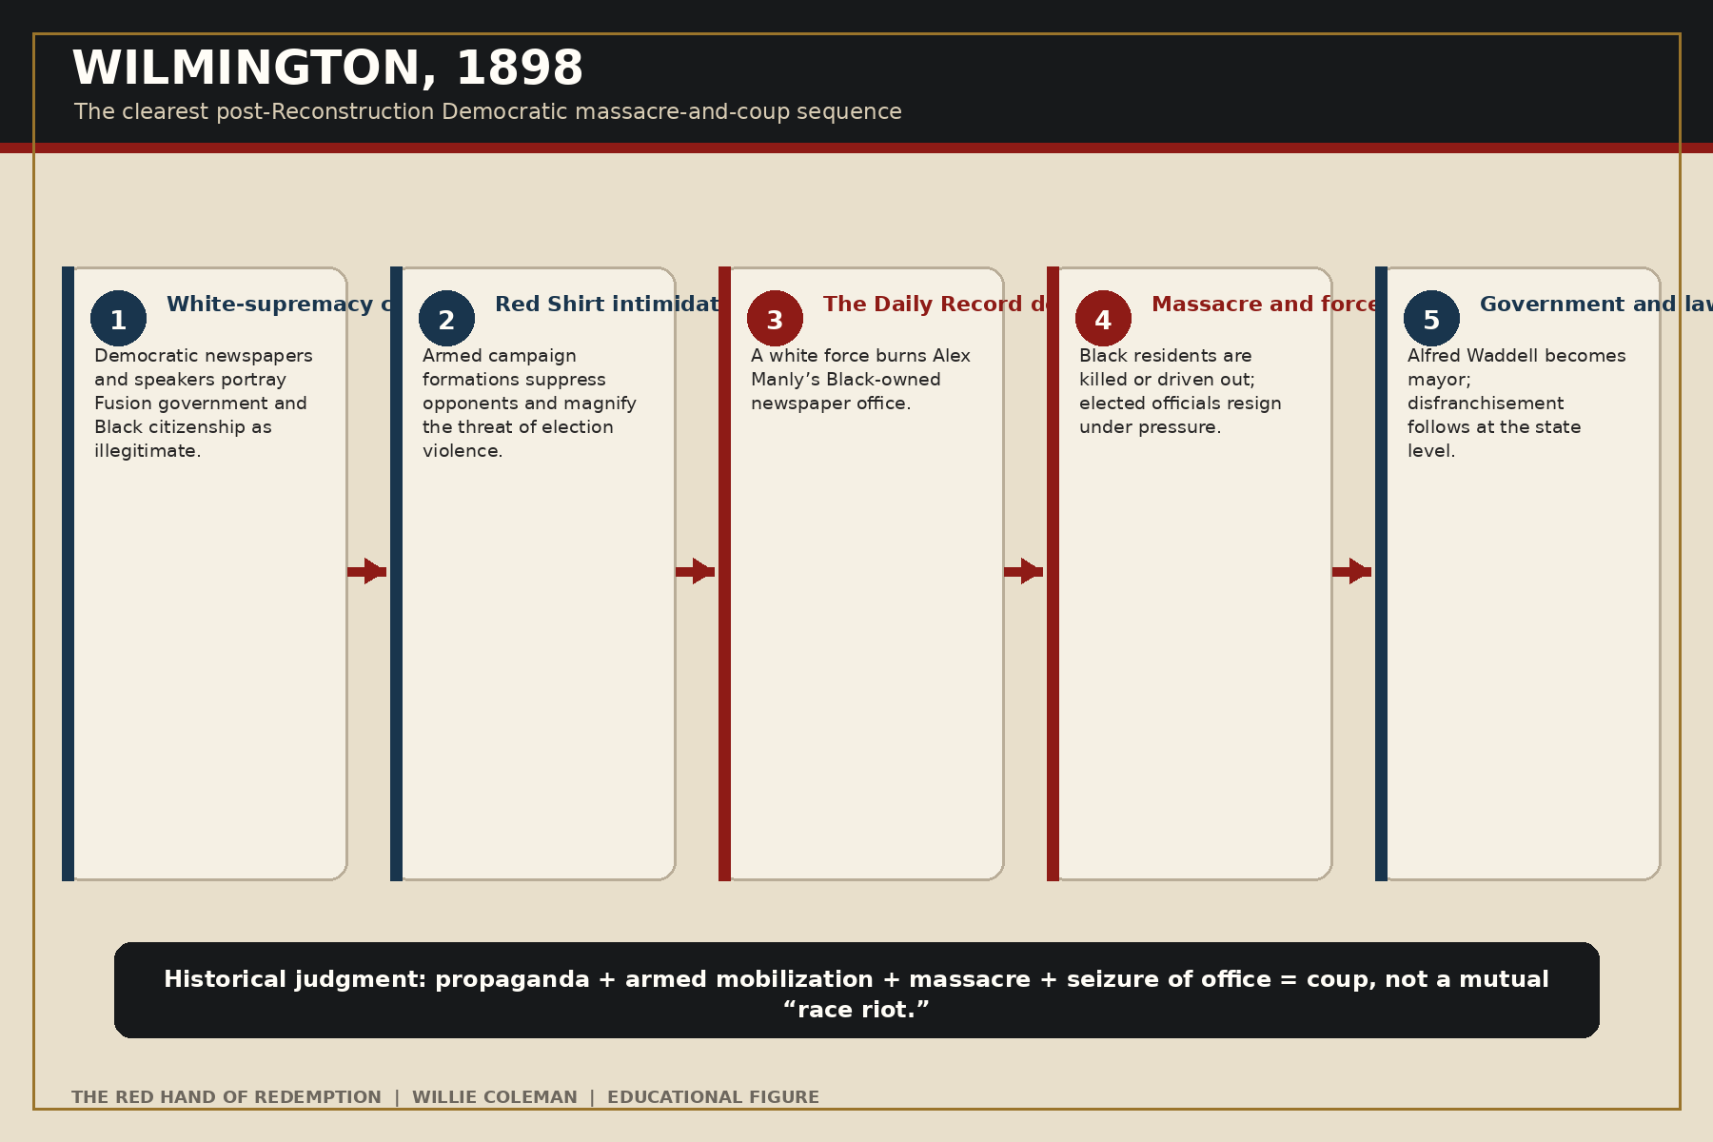
Figure 5. Wilmington, 1898: propaganda, armed mobilization, massacre, coup, and disfranchisement.

9. The Second Klan and the One-Party South
The second Ku Klux Klan, founded in 1915, was not simply the first Klan reborn. It was a national mass-membership organization with paid recruiters, commercial rituals, and a broader list of targets that included Catholics, Jews, immigrants, labor radicals, and others alongside Black Americans. It became powerful in states outside the former Confederacy and penetrated both major parties depending on local conditions.
That national complexity does not erase the South’s political structure. By the early twentieth century, disfranchisement had produced a one-party Democratic region. Primaries frequently mattered more than general elections. Sheriffs, judges, registrars, prosecutors, governors, and legislators generally operated inside Democratic systems. A Klansman who held local office in such a state was often a Democrat because meaningful white politics occurred within that party. But one-party context alone does not prove that a Democratic committee ordered each Klan crime.

Ocoee, 1920
Ocoee, Florida, demonstrates the connection between Klan intimidation, voting, massacre, and land loss. Before the 1920 election, the revived Klan threatened Black political participation. When Black residents attempted to vote, a confrontation escalated into a white attack on the Black community. Homes and churches were burned, residents were killed, and surviving Black families were driven from Ocoee. Their property passed out of Black hands.
The casualty count remains uncertain; common estimates range from roughly thirty to eighty Black victims. The Klan’s pre-election threat is well documented, while a formal Klan command directing every stage of the massacre is less certain. Florida’s Democratic one-party order shaped the environment, but a complete book must still identify polling officials, sheriffs, posses, attackers, and property beneficiaries individually. Ocoee is therefore D2/K2 in the evidence system.

Tulsa and Rosewood: necessary boundaries
Tulsa in 1921 is one of the most devastating massacres in American history. The Justice Department’s 2025 review found that white Tulsans mounted an organized assault on Greenwood and that police deputized white civilians, helped organize attacking forces, and participated in disarming and detaining Black residents. More than 1,250 homes were burned, thousands were left homeless, and estimates of the dead reach into the hundreds.
The Klan existed in Tulsa and soon became politically powerful. But official investigations have not established that the Klan commanded the massacre. Nor does the available record prove Democratic Party direction. Tulsa belongs in the larger history of state-assisted white mob violence, but presenting it as a Democratic Klan operation would substitute assumption for evidence.
Rosewood, Florida, in 1923 presents a similar boundary. A white mob destroyed the Black community after a false or unsubstantiated accusation. At least six Black residents and two white attackers were killed, with higher estimates disputed. Some Klansmen reportedly participated, yet available evidence does not establish Klan organizational command or Democratic committee direction. Florida’s later compensation process and historical investigation belong in the story of recovery and memory.
These exclusions strengthen the argument. A book committed to suppressed facts cannot create new myths. The Democratic-Klan connection is powerful where the record proves it. It should not be enlarged by attaching every massacre to the same command structure.

10. Bombingham and Mississippi Burning
By the civil-rights era, national party conflict over race had become visible and consequential. Southern segregationist Democratic state and local systems remained powerful, while Democratic presidents and members of Congress increasingly supported federal civil-rights enforcement. Klan cells operated inside communities where police, sheriffs, juries, employers, and white citizens’ organizations could provide information, indifference, protection, or direct assistance.

Sixteenth Street Baptist Church
On September 15, 1963, a bomb exploded at Birmingham’s Sixteenth Street Baptist Church, killing Addie Mae Collins, Denise McNair, Carole Robertson, and Cynthia Wesley and injuring more than twenty people. The church was a center of civil-rights organizing. Federal investigators identified Klan suspects, but successful prosecutions took years. Robert Chambliss was convicted in 1977; Thomas Blanton Jr. in 2001; and Bobby Frank Cherry in 2002.
The FBI now states plainly that the Klan was behind the bombing and acknowledges that local obstruction and the Bureau’s own misplaced priorities impeded justice. Birmingham’s segregationist government and police culture formed the setting, but the evidence does not show that the national Democratic Party ordered the bombing. The accurate formulation is D1/K3: proven Klan responsibility inside a segregationist local order, with later state and federal action against the perpetrators.
The prosecution led by Alabama Attorney General Bill Baxley is important counterevidence. Historical institutions contain conflict. A Democratic officeholder could act against crimes committed in a Democratic-dominated state. Recording that fact does not cancel the earlier system; it prevents the book from treating a party label as a timeless personal essence.

Neshoba County
In June 1964, civil-rights workers James Chaney, Andrew Goodman, and Michael Schwerner disappeared after investigating a church burning in Mississippi. Members of the White Knights of the Ku Klux Klan conspired with Neshoba County Deputy Sheriff Cecil Price to abduct and murder them. Federal investigation eventually located the bodies and produced civil-rights convictions. Edgar Ray Killen was convicted on state manslaughter charges in 2005.
Neshoba shows the most dangerous form of local penetration: the badge and the Klan working together. It also shows the changing national alignment. President Lyndon B. Johnson’s administration pursued the investigation and signed the Civil Rights Act of 1964 and Voting Rights Act of 1965. The crime arose inside Mississippi’s segregationist Democratic order, while a Democratic national administration used federal power against that order.
The historical conclusion is neither that party history stopped mattering nor that every Democrat had the same position. The conclusion is that local one-party systems can shelter terror, and that national enforcement can rupture those systems. The relevant unit of analysis is the actor, office, organization, action, and date—not a party label floating free of time.

Part IV — How the Record Was Suppressed

11. The Vocabulary of Innocence
Political violence is often suppressed first through naming. “Riot” implies mutual disorder. “Insurrection” assigns rebellion to the victims. “Home rule” turns the withdrawal of protection into democratic restoration. “Redemption” gives a sacred name to the recovery of white power. “Carpetbag misrule” converts elected government into foreign occupation. Each phrase arranges sympathy before the facts are heard.
At Colfax, a massacre of surrendering Black defenders became a riot that supposedly ended corrupt rule. At Wilmington, an organized campaign and coup became a race riot. At Liberty Place, armed attackers of the state became civic heroes. In Elaine, Black sharecroppers organizing for fair accounting were prosecuted through a story of Black insurrection while white posses and troops killed Black residents. In Tulsa, officials confined survivors and protected the city from liability while describing the devastation as riot damage.

Victim criminalization
The recurring narrative begins by making Black organization suspicious. A Republican meeting becomes incitement. A militia becomes a dangerous mob. A labor union becomes conspiracy. A newspaper editorial becomes an attack on white womanhood. Armed self-defense becomes proof that whites acted defensively. Once the victim is recast as the aggressor, the attacker can appear as law and order.
This narrative was especially effective because white officials often controlled the records that survived. Sheriffs decided whom to arrest. Coroners decided whose death was counted. Prosecutors decided whom to charge. Newspapers selected witnesses and headlines. Courts accepted some testimony and rejected other testimony. Property records documented later transfers without recording the coercion that caused them.

Fatality fog
Massacre numbers are frequently unstable. Bodies were removed, burned, buried privately, thrown into water, or carried away by families. Refugees vanished from local records. White officials undercounted, and later writers sometimes inflated estimates without traceable evidence. A responsible historian must preserve ranges, separate documented names from estimates, and avoid summing incompatible figures into a false national total.
Names are more important than dramatic arithmetic. A named victim can be connected to family, occupation, office, property, church, party activity, and descendants. A number expresses scale; a roster restores social existence. The next research edition of this book should continue building named victim and perpetrator files from federal testimony, death records, newspapers, cemetery records, deeds, and family archives.

The Dunning tradition and popular culture
For decades, influential historical writing portrayed Reconstruction as an era of Black incapacity, Northern exploitation, and Southern victimization. W. E. B. Du Bois’s Black Reconstruction in America challenged that framework by centering Black labor, citizenship, and the democratic possibilities of the period. Later historians, including John Hope Franklin and Eric Foner, dismantled the older narrative through wider use of Black sources, political records, and social history.
Popular culture often moved in the opposite direction. The Birth of a Nation presented the Klan as savior and helped inspire the second Klan. Memorial organizations preserved a Lost Cause in which former Confederates defended civilization. The result was not simply inaccurate memory. It shaped public sympathy toward voting rights, federal enforcement, monuments, and the legitimacy of Black officeholding.

Klan over-branding
Modern memory sometimes commits an opposite error by calling all organized white violence “the KKK.” That shortcut can hide the directness of public Democratic paramilitary power. The White League marched openly. Red Shirts campaigned openly. Wilmington’s coup leaders published demands and assumed office. Their lack of hoods did not make their political violence less organized.
The fullest history therefore follows the organization through its names without losing the system. Klan, White Camelia, White League, rifle club, Red Shirt, posse, police force, and mob are not interchangeable. But they could occupy adjacent positions in a movement to remove Black Republicans and restore white Democratic government.
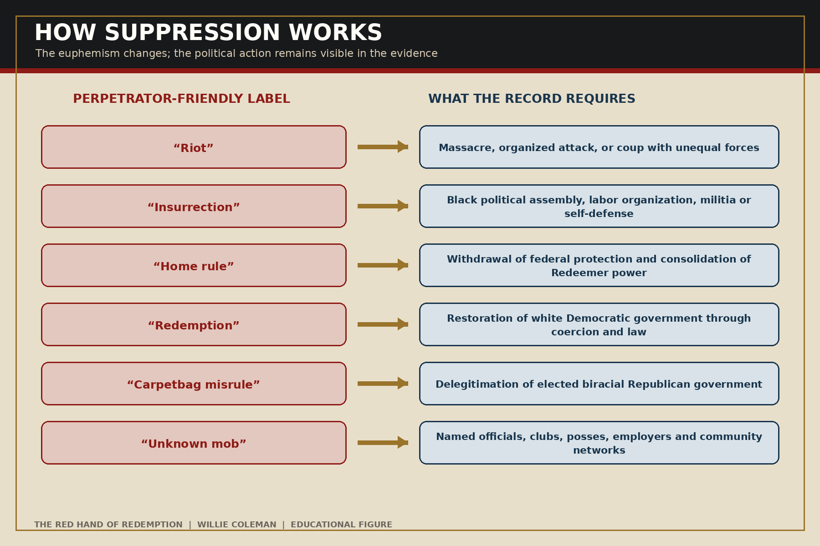
Figure 6. How euphemistic language suppresses political responsibility.

12. What Redemption Destroyed
The most important measure of Redemption is not the number of Democratic offices gained. It is the public world that disappeared. Black voters lost meaningful access to the ballot. Black officials vanished from legislatures and courthouses. Public education became segregated and unequal. Jury service narrowed. Civil-rights protections weakened. Labor and land claims were enforced inside governments answerable to a drastically reduced electorate.
Rayford Logan described the period after Reconstruction as a betrayal and a nadir in Black history. His framework connects federal retreat to disfranchisement, lynching, segregation, and the abandonment of equal citizenship. The betrayal was not only that national Republicans compromised or withdrew. It was that the United States allowed constitutional rights to become locally optional.
Louisiana provides a concentrated example. Black political power in the Reconstruction legislature, documented by Charles Vincent, existed beside extraordinary violence in New Orleans, Opelousas, Colfax, Coushatta, and Liberty Place. After Redemption, the state’s 1898 constitution employed devices designed to reduce Black voting dramatically. Violence and law were successive stages of the same transfer of power.
The economic consequences also deserve fuller measurement. When a family fled Ocoee, Wilmington, or another terrorized community, it lost more than a house. It lost land appreciation, business income, customers, tools, credit relationships, inheritance, school continuity, and political influence. Descendants inherited absence. Parcel-level research can convert general statements about stolen opportunity into documented chains of ownership and value.

The final judgment
The first Reconstruction Klan was a violent instrument of the movement to restore Southern Democratic rule and white supremacy. It attacked the people and institutions that made Black Republican citizenship possible. When federal power damaged the Klan, open Democratic-aligned forces continued the counterrevolution. Their violence altered elections and governments. Redeemer governments then converted victory into constitutions, laws, administration, and memory.
This judgment does not require claiming that a national Democratic committee founded the Klan or issued orders for every attack. Former Confederates founded the first Klan, and its decentralized structure rarely left the paperwork of a modern bureaucracy. The stronger historical claim is functional and demonstrable: the Klan’s targets, allies, timing, testimony, and electoral effects served the restoration of Democratic power.
Nor does the judgment require forcing Tulsa, Rosewood, Elaine, Moore’s Ford, or every later Klan crime into the same category. Some events reveal state-assisted white violence without proven party direction. Some reveal Klan-local government cooperation during a period of national party change. Evidence should decide the code.
The suppressed history is therefore not that one party possessed a permanent racial character while the other remained innocent. It is that a specific counterrevolution—organized largely through the Southern Democratic Party and its armed allies—destroyed an extraordinary expansion of Black Republican political power. That fact can be documented without exaggeration. It should be taught without apology.

Epilogue: The Ballot Box Still Stands
The image at the center of this book is not the hood. It is the ballot box. The hood mattered because of what stood beside it: a registered voter, an election manager, a teacher, a newspaper editor, a militia captain, a legislator, a sheriff, a farmer who owned his land, and a congregation willing to host a meeting.
Terrorists understood power in practical terms. They knew that citizenship lived in habits and institutions. A constitutional amendment required people willing to register. A vote required a road to the polling place. An election required managers willing to count honestly. An office required a person willing to serve after threats. A school required a building that had not been burned. A newspaper required a press that had not been destroyed.
That is why the victims’ political identities must be restored. They were not only Black bodies in a casualty total. They were Republicans, Unionists, Fusionists, organizers, veterans, workers, landowners, parents, and citizens. They represented a future their attackers intended to prevent.
Reconstruction’s unfinished work is not rescued by nostalgia. It is rescued by evidence: testimony read closely, names recovered, affiliations dated, property traced, votes counted, and euphemisms removed. The ballot box still stands as the proper center of the story because it shows both what was built and why the Red Hand moved against it.

Appendix A — Evidence and Attribution Code

Democratic-party connection
D3 — Direct or functional tie. The force was a Democratic campaign organization; leaders were Democratic candidates or officials acting for an electoral objective; or reliable primary records and scholarship establish a military or paramilitary role in restoring Democratic rule.
D2 — Strong alliance. Democratic clubs, newspapers, candidates, or officials recruited, armed, praised, protected, or politically benefited from the force, but a formal command chain is incomplete.
D1 — Governmental context or individual complicity. Democratic officials or a Democratic local regime enabled or participated, without evidence that the party directed the crime.
D0 — No adequate party link proved. One-party geography, later voting behavior, or the presence of individual Democrats is insufficient.

Klan connection
K3 — Confirmed. A Klan chapter, cell, member confession, prosecution, or authoritative institutional finding confirms responsibility.
K2 — Strongly connected. Klan members reportedly participated or several credible sources connect the Klan, but organizational command is incomplete.
K1 — Alleged or atmospheric. Klan presence, later association, or an unverified allegation exists, but incident responsibility is not established.
K0 — Different force. The responsible formation was another named organization or public body; it should not be called the Klan.

Confidence
High means primary records or an official inquiry plus strong scholarly agreement. Moderate means the event and political function are secure but casualty totals, membership, or command details remain disputed. Limited identifies a serious lead that requires additional archival confirmation before categorical publication.
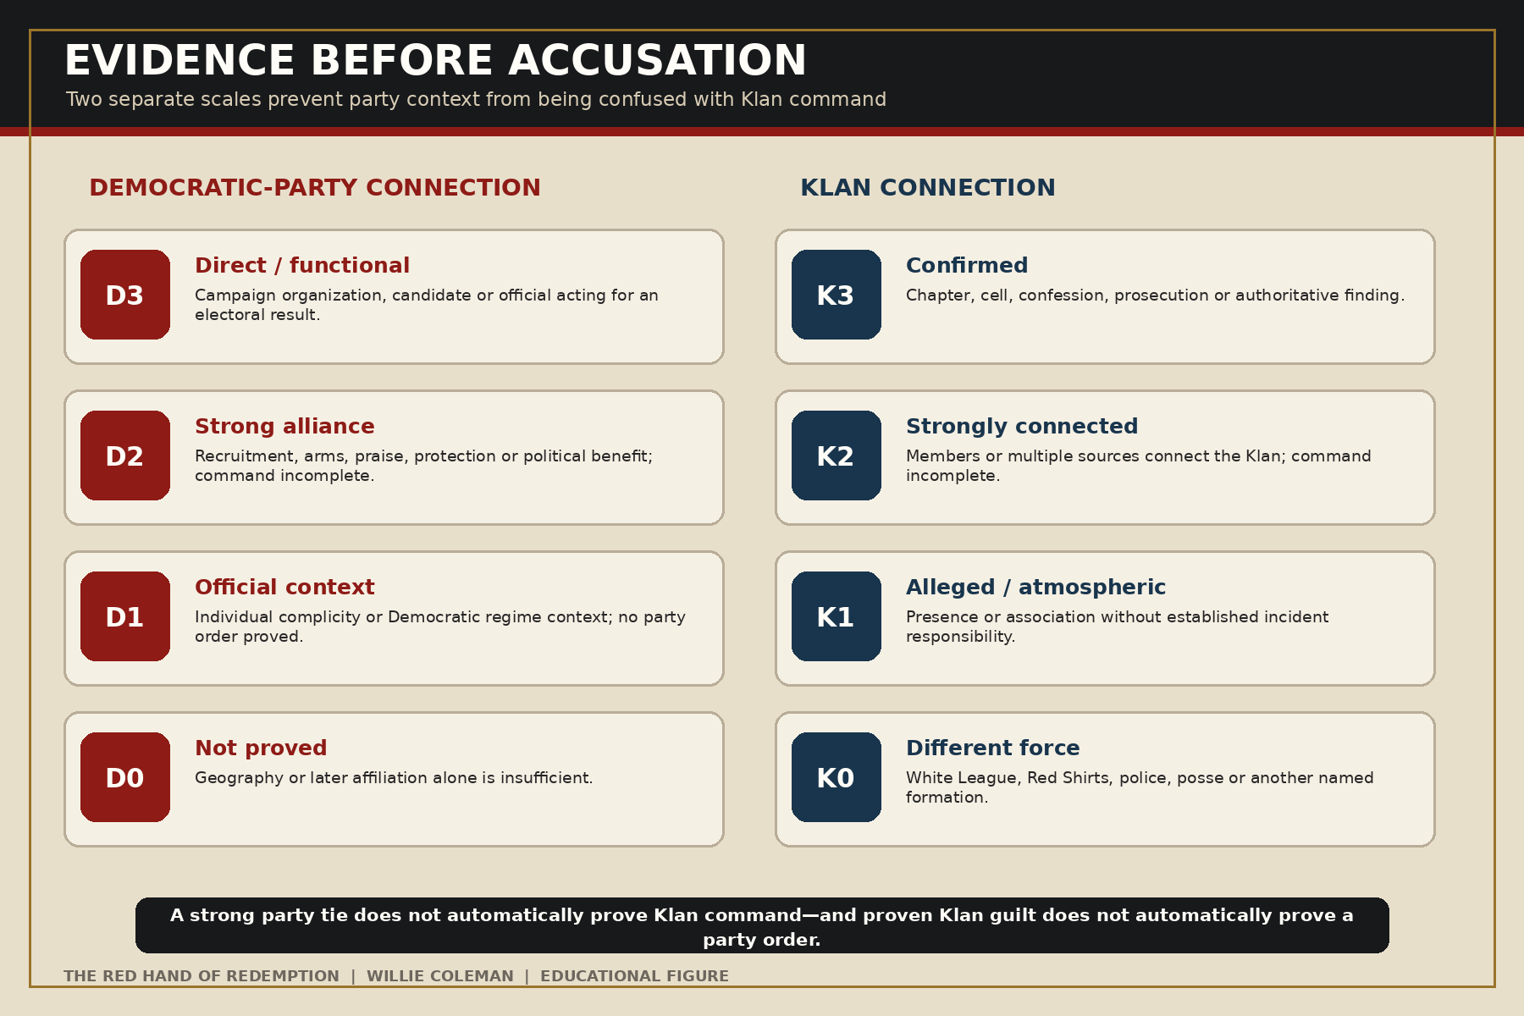
Figure 7. The D/K evidence matrix separates party connection from Klan responsibility.

Appendix B — National Incident Ledger
Date and place | Reported victims | Force | Codes | Historical judgment
1866, Memphis, Tennessee | 46 Black people; 2 white people | Police, firemen, white mobs | D1/K0 | Municipal complicity established; direct party operation requires more proof.
1866, New Orleans, Louisiana | Dozens, overwhelmingly Black and convention supporters | Democratic city police and armed opponents | D3/K0 | Direct assault on a Republican constitutional meeting.
1868, Camilla, Georgia | About 9–15 Black people | White townsmen and local officials | D3/K1 | Republican rally blocked for an electoral purpose; formal Klan command unproved.
1868, Opelousas, Louisiana | More than 200 in a leading modern account | Armed white Democrats and allied secret orders | D3/K2 | Mass voter suppression producing Democratic control.
1869–1871, Jackson County, Florida | Roughly 100; estimates vary | Klan networks and Young Men’s Democratic Clubs | D3/K3 | Serial assassination dismantled county Republican power.
1870, Eutaw, Alabama | At least 4 Black people | Klan gunmen | D3/K3 | Attack on Republican gathering suppressed turnout.
1870, Laurens County, South Carolina | At least a dozen reported | Klan and white mobs | D3/K3 | Post-election attack on Republican leadership.
1871, Union County, South Carolina | 12 Black prisoners | Klan jail raiders | D3/K3 | Confirmed Klan campaign against Black militia and Republicans.
1871, Meridian, Mississippi | As many as 30 total; disputed | White Democrats and Klan-aligned vigilantes | D2/K2 | Political setting clear; sequence and command disputed.
1873, Colfax, Louisiana | At least 60; perhaps more than 100 Black men | Nash’s Democratic/Fusionist force | D3/K2 | Courthouse massacre arising from disputed Republican government.
1874, Coushatta, Louisiana | 6 white Republican officials and Black supporters | White League | D3/K0 | Open Democratic-aligned paramilitary murder.
1874, Vicksburg, Mississippi | Dozens; estimates exceed 100 | Armed Democratic clubs and paramilitaries | D3/K1 | Overthrow of Black Republican county power.
1874, Liberty Place, New Orleans | More than 30 total | White League | D3/K0 | Attempted coup against Louisiana’s Republican government.
1875, Clinton, Mississippi | Common estimates 30–50 Black people | Democratic rifle-club forces | D3/K1 | Mississippi Plan election terror; casualty audit needed.
1876, Hamburg, South Carolina | 6 Black men; 1 white man | Red Shirts and rifle clubs | D3/K0 | Prisoners murdered in Democratic campaign violence.
1876, Ellenton, South Carolina | At least 30; perhaps more | Red Shirts and rifle clubs | D3/K0 | Statewide Redemption and voter-suppression campaign.
1878, Caddo Parish, Louisiana | Historical summaries cite 40–75 Black people | Klan gunmen | D3/K3 | Election terror serving Democratic restoration; roster needed.
1883, Danville, Virginia | At least 5, including 4 Black men | White Democratic crowd and militia actors | D3/K0 | Campaign violence used against biracial Readjuster rule.
1886, Carrollton, Mississippi | Roughly 20–24 Black people | Courthouse mob | D2/K1 | Context strong; command evidence remains limited.
1887, Thibodaux, Louisiana | At least 30; credible higher estimates | Sheriff’s posse and planter militia | D2/K0 | Labor massacre within Democratic state power; not proven Klan.
1898, Wilmington, North Carolina | Official commission: as many as 60 Black people | Democratic white-supremacy campaign and Red Shirts | D3/K0 | Massacre and coup replacing elected government.
1920, Ocoee, Florida | Common estimates 30–80 Black people | White mob following Klan voting threats | D2/K2 | Klan intimidation established; full command chain incomplete.
1921, Tulsa, Oklahoma | Estimates reach 300 | Mob, deputized civilians, public authorities | D0/K1 | State-assisted massacre; Klan and party command unproved.
1923, Rosewood, Florida | At least 6 Black people; higher estimates disputed | White mob; reported Klan participation | D0/K2 | No adequate proof of party direction.
1946, Moore’s Ford, Georgia | 4 Black people | Lynching mob; Klan suspected | D0/K2 | Party command unproved; governor sought federal help.
1963, Birmingham, Alabama | 4 Black girls; more than 20 injured | Klan bombers | D1/K3 | Proven Klan crime inside segregationist local order.
1964, Neshoba County, Mississippi | 3 civil-rights workers | White Knights with Deputy Sheriff Cecil Price | D1/K3 | Proven Klan–law-enforcement conspiracy.

Appendix C — Primary-Source Research Map
- Federal Reconstruction record: Joint Select Committee testimony; Freedmen’s Bureau reports; Army district reports; Department of Justice prosecution files; Congressional Globe debates; Grant proclamations; federal election-supervisor reports.
- State and local government: coroner inquests, grand juries, criminal dockets, sheriffs’ records, militia rosters, governor papers, election returns, voter registration, tax rolls, deeds, compensation claims, and legislative journals.
- Black testimony and press: Christian Recorder, New National Era, New Orleans Tribune, Black convention proceedings, church minutes, NAACP files, survivor affidavits, oral histories, family papers, funeral programs, and cemetery records.
- Adversarial white sources: Democratic campaign newspapers, party convention proceedings, White League platforms, Red Shirt speeches, rifle-club rosters, Klan confessions, defense testimony, monument inscriptions, and Lost Cause histories.
- Political measurement: precinct returns before and after violence; registration changes; officeholder resignations; contested-election files; migration; land transfer; business destruction; school closure; and jury composition.
- Claim discipline: record the strongest evidence against the working conclusion; distinguish allegation, indictment, conviction, official finding, and historian inference; preserve alternative casualty estimates with their derivations.

Appendix D — Black Political Power Research Roster
The following figures and groups should anchor the biographical expansion of future editions: Oscar J. Dunn; P. B. S. Pinchback; Joseph H. Rainey; Robert Brown Elliott; Robert C. De Large; Robert Smalls; Hiram Revels; Blanche K. Bruce; Josiah T. Walls; Abram Colby; Wade Perrin; Black delegates to Louisiana’s constitutional conventions; Grant Parish Republican officials and courthouse defenders; Red River Parish officeholders murdered at Coushatta; Hamburg militia members; Wilmington aldermen, businessmen, educators, and newspaper workers; and the unnamed local election managers appearing throughout federal Klan testimony.
Each profile should contain: birth and family; enslavement or free status; education; military service; church and civic networks; party activity; offices held; policy work; threats and attacks; property; migration; descendants; and the documentary trail by which the life can be recovered.

Notes
This edition places numbered source notes at the foot of the page where each claim appears. Books are cited with full publication information at first use; institutional records include the responsible office, document title, and stable web address when available. Online sources were last verified on August 20, 2026.
Casualty figures remain ranges when the record does not support a single number. A citation to an official commission or modern historian establishes the source of the range; it does not imply that every victim has been individually identified. The incident ledger marks entries that still require a victim-by-victim archival audit.
Primary-source quotations have been kept short and attached to an identifiable speaker or document. Claims about organizational or party responsibility follow the D/K evidence system in Appendix A. Where historians disagree about command, membership, sequence, or totals, the text states the narrower conclusion and preserves the dispute.

Selected Bibliography
Blair, William A. The Record of Murders and Outrages: Racial Violence and the Fight over Truth at the Dawn of Reconstruction. Chapel Hill: University of North Carolina Press, 2021.
Budiansky, Stephen. The Bloody Shirt: Terror after Appomattox. New York: Viking, 2008.
Cecelski, David S., and Timothy B. Tyson, eds. Democracy Betrayed: The Wilmington Race Riot of 1898 and Its Legacy. Chapel Hill: University of North Carolina Press, 1998.
Du Bois, W. E. B. Black Reconstruction in America, 1860–1880. New York: Harcourt, Brace, 1935.
Foner, Eric. Freedom’s Lawmakers: A Directory of Black Officeholders During Reconstruction. Revised edition. Baton Rouge: Louisiana State University Press, 1996.
———. Reconstruction: America’s Unfinished Revolution, 1863–1877. New York: Harper & Row, 1988.
Franklin, John Hope. Reconstruction after the Civil War. Chicago: University of Chicago Press, 1961.
Gordon, Linda. The Second Coming of the KKK. New York: Liveright, 2017.
Hahn, Steven. A Nation Under Our Feet: Black Political Struggles in the Rural South from Slavery to the Great Migration. Cambridge, MA: Harvard University Press, 2003.
Keith, LeeAnna. The Colfax Massacre: The Untold Story of Black Power, White Terror, and the Death of Reconstruction. New York: Oxford University Press, 2008.
Lane, Charles. The Day Freedom Died: The Colfax Massacre, the Supreme Court, and the Betrayal of Reconstruction. New York: Henry Holt, 2008.
Lemann, Nicholas. Redemption: The Last Battle of the Civil War. New York: Farrar, Straus and Giroux, 2006.
Logan, Rayford W. The Betrayal of the Negro: From Rutherford B. Hayes to Woodrow Wilson. New York: Collier, 1965.
MacLean, Nancy. Behind the Mask of Chivalry: The Making of the Second Ku Klux Klan. New York: Oxford University Press, 1994.
Moore, Leonard J. Citizen Klansmen: The Ku Klux Klan in Indiana, 1921–1928. Chapel Hill: University of North Carolina Press, 1991.
Ortiz, Paul. Emancipation Betrayed: The Hidden History of Black Organizing and White Violence in Florida from Reconstruction to the Bloody Election of 1920. Berkeley: University of California Press, 2005.
Parsons, Elaine Frantz. Ku-Klux: The Birth of the Klan during Reconstruction. Chapel Hill: University of North Carolina Press, 2015.
Rable, George C. But There Was No Peace: The Role of Violence in the Politics of Reconstruction. Athens: University of Georgia Press, 1984.
Trelease, Allen W. White Terror: The Ku Klux Klan Conspiracy and Southern Reconstruction. New York: Harper & Row, 1971.
Umfleet, LeRae. A Day of Blood: The 1898 Wilmington Race Riot. Raleigh: North Carolina Office of Archives and History, 2009; revised edition, 2020.
Vincent, Charles. Black Legislators in Louisiana During Reconstruction. Carbondale: Southern Illinois University Press, 1976.
Weinfeld, Daniel R. The Jackson County War: Reconstruction and Resistance in Post-Civil War Florida. Tuscaloosa: University of Alabama Press, 2012.
Williams, Kidada E. I Saw Death Coming: A History of Terror and Survival in the War Against Reconstruction. New York: Bloomsbury, 2023.
———. They Left Great Marks on Me: African American Testimonies of Racial Violence from Emancipation to World War I. New York: New York University Press, 2012.

About the Author
Willie Coleman is a Louisiana writer, researcher, producer, engineer, and inventor whose historical work examines the relationship between race, political power, public policy, and the American record. His companion projects include Red Roots, a Reconstruction-era historical novel, and The American Racial Record, an evidence-led reference history of politicians, parties, civil rights, and measurable outcomes.

Eric Foner, Freedom’s Lawmakers: A Directory of Black Officeholders During Reconstruction, rev. ed. (Baton Rouge: Louisiana State University Press, 1996); Charles Vincent, Black Legislators in Louisiana During Reconstruction (Carbondale: Southern Illinois University Press, 1976).
Office of the Historian, U.S. House of Representatives, “The Fifteenth Amendment in Flesh and Blood,” in Black Americans in Congress, accessed August 20, 2026, https://history.house.gov/Exhibitions-and-Publications/BAIC/Historical-Essays/Introduction/Reconstruction-Generation/.
Eric Foner, A Short History of Reconstruction, 1863–1877 (New York: Harper & Row, 1990), chapter 9; excerpt hosted by New York Public Library, https://www.nypl.org/sites/default/files/foner_-_preface_chapter_9_1.pdf.
Elaine Frantz Parsons, Ku-Klux: The Birth of the Klan during Reconstruction (Chapel Hill: University of North Carolina Press, 2015); Allen W. Trelease, White Terror: The Ku Klux Klan Conspiracy and Southern Reconstruction (New York: Harper & Row, 1971).
Office of the Historian, U.S. House of Representatives, “Joseph Hayne Rainey,” accessed August 20, 2026, https://history.house.gov/People/Detail/20095.
Foner, Freedom’s Lawmakers; Vincent, Black Legislators; Office of the Historian, U.S. House of Representatives, Black Americans in Congress, 1870–2022 (Washington, DC: Government Publishing Office, 2023), https://www.govinfo.gov/content/pkg/GPO-CDOC-118hdoc16/.
Eric Foner, “A History of the Democratic Party,” review of Michael Kazin, What It Took to Win, London Review of Books, May 12, 2022, https://ericfoner.com/reviews/051222lrb.html.
U.S. Congress, House, Select Committee on the Memphis Riots, Memphis Riots and Massacres, 39th Cong., 1st sess., H. Rep. 101 (1866); Equal Justice Initiative, Reconstruction in America: Racial Violence after the Civil War, 1865–1876 (2017), https://eji.org/report/reconstruction-in-america/.
U.S. Congress, House, Select Committee on the New Orleans Riots, New Orleans Riots, 39th Cong., 2d sess., H. Rep. 16 (1867); James G. Hollandsworth Jr., An Absolute Massacre: The New Orleans Race Riot of July 30, 1866 (Baton Rouge: Louisiana State University Press, 2001).
New Georgia Encyclopedia, “Camilla Massacre,” https://www.georgiaencyclopedia.org/articles/history-archaeology/camilla-massacre/.
64 Parishes, “Opelousas Massacre of 1868,” https://64parishes.org/entry/opelousas-massacre-of-1868; Ted Tunnell, The Edge of the Sword: The Ordeal of Carpetbagger Marshall H. Twitchell in the Civil War and Reconstruction (Baton Rouge: Louisiana State University Press, 2001).
U.S. Congress, Joint Select Committee, Report of the Joint Select Committee to Inquire into the Condition of Affairs in the Late Insurrectionary States, 42nd Cong., 2d sess., H. Rep. 22, testimony of Abram Colby (Washington: Government Printing Office, 1872).
Daniel R. Weinfeld, The Jackson County War: Reconstruction and Resistance in Post-Civil War Florida (Tuscaloosa: University of Alabama Press, 2012).
Encyclopedia of Alabama, “Eutaw,” https://encyclopediaofalabama.org/article/eutaw/.
U.S. Congress, Joint Select Committee, Condition of Affairs in the Late Insurrectionary States, South Carolina testimony; Lou Falkner Williams, The Great South Carolina Ku Klux Klan Trials, 1871–1872 (Athens: University of Georgia Press, 1996).
Library of Congress, “The Ku-Klux Reign of Terror: Synopsis of a Portion of the Testimony Taken by the Congressional Investigating Committee,” no. 5 (1872), https://www.loc.gov/resource/rbpe.23700800/.
Library of Congress, catalog record and digital volumes, Report of the Joint Select Committee … Late Insurrectionary States (1872), https://www.loc.gov/item/35031867/.
Kidada E. Williams, They Left Great Marks on Me: African American Testimonies of Racial Violence from Emancipation to World War I (New York: New York University Press, 2012); Kidada E. Williams, I Saw Death Coming: A History of Terror and Survival in the War Against Reconstruction (New York: Bloomsbury, 2023).
U.S. Senate Historical Office, “The Enforcement Acts of 1870 and 1871,” https://www.senate.gov/artandhistory/history/common/generic/EnforcementActs.htm.
Office of the Historian, U.S. House of Representatives, entries for Joseph Rainey and Robert C. De Large in Black Americans in Congress.
Federal Judicial Center, “The South Carolina Ku Klux Klan Trials of 1871–1872,” https://www.fjc.gov/history/spotlight-judicial-history/ku-klux-klan-trials-1871-1872.
Ku Klux Klan Act of 1871, ch. 22, 17 Stat. 13; District of Columbia v. Carter, 409 U.S. 418 (1973).
LeeAnna Keith, The Colfax Massacre: The Untold Story of Black Power, White Terror, and the Death of Reconstruction (New York: Oxford University Press, 2008); 64 Parishes, “Colfax Massacre,” https://64parishes.org/entry/colfax-massacre-adaptation.
United States v. Cruikshank, 92 U.S. 542 (1876); 64 Parishes, “Cruikshank Case,” https://64parishes.org/entry/cruikshank-case.
64 Parishes, “White League,” https://64parishes.org/entry/white-league-adaptation.
64 Parishes, “Coushatta Massacre,” https://64parishes.org/entry/coushatta-massacre.
64 Parishes, “Battle of Liberty Place,” https://64parishes.org/entry/battle-of-liberty-place.
U.S. Congress, Senate, South Carolina in 1876, 44th Cong., 2d sess., S. Rep. 611 (1877); Stephen Budiansky, The Bloody Shirt: Terror after Appomattox (New York: Viking, 2008).
George C. Rable, But There Was No Peace: The Role of Violence in the Politics of Reconstruction (Athens: University of Georgia Press, 1984); Nicholas Lemann, Redemption: The Last Battle of the Civil War (New York: Farrar, Straus and Giroux, 2006).
John DeSantis, The Thibodaux Massacre: Racial Violence and the 1887 Sugar Cane Labor Strike (Charleston: History Press, 2016); Equal Justice Initiative, Reconstruction in America.
LeRae Umfleet, A Day of Blood: The 1898 Wilmington Race Riot (Raleigh: North Carolina Office of Archives and History, 2009; rev. ed. 2020).
North Carolina Department of Natural and Cultural Resources, “1898 Wilmington Coup,” https://www.ncdcr.gov/1898-wilmington-coup; Wilmington Race Riot Commission, 1898 Wilmington Race Riot Report (2006), https://digital.ncdcr.gov/Documents/Detail/1898-wilmington-race-riot-report/2257408.
Nancy MacLean, Behind the Mask of Chivalry: The Making of the Second Ku Klux Klan (New York: Oxford University Press, 1994); Linda Gordon, The Second Coming of the KKK (New York: Liveright, 2017); Leonard J. Moore, Citizen Klansmen (Chapel Hill: University of North Carolina Press, 1991).
Paul Ortiz, Emancipation Betrayed: The Hidden History of Black Organizing and White Violence in Florida from Reconstruction to the Bloody Election of 1920 (Berkeley: University of California Press, 2005); University of Florida Digital Newspaper Project, “The Ocoee Massacre,” https://ufndnp.domains.uflib.ufl.edu/ocoee-massacre-a-tragic-day-in-florida-history-ufndnp/.
U.S. Department of Justice, Civil Rights Division, Review and Evaluation of the Tulsa Race Massacre (2025), https://www.justice.gov/crt/media/1383756/dl.
Florida Division of Library and Information Services, “Rosewood,” https://dos.fl.gov/library-archives/research/explore-our-resources/florida-history-culture-and-heritage/rosewood/.
Federal Bureau of Investigation, “Baptist Street Church Bombing,” https://www.fbi.gov/history/cases-and-criminals/baptist-street-church-bombing.
Christopher Wray, “Remarks at the 2024 Birmingham Civil Rights Conference,” Federal Bureau of Investigation, April 15, 2024, https://www.fbi.gov/news/speeches-and-testimony/director-wrays-remarks-at-the-2024-birmingham-civil-rights-conference.
Federal Bureau of Investigation, “Mississippi Burning,” https://www.fbi.gov/history/cases-and-criminals/mississippi-burning; United States v. Price, 383 U.S. 787 (1966).
W. E. B. Du Bois, Black Reconstruction in America, 1860–1880 (New York: Harcourt, Brace, 1935); John Hope Franklin, Reconstruction after the Civil War (Chicago: University of Chicago Press, 1961); Eric Foner, Reconstruction: America’s Unfinished Revolution, 1863–1877 (New York: Harper & Row, 1988).
Rayford W. Logan, The Betrayal of the Negro: From Rutherford B. Hayes to Woodrow Wilson (New York: Collier, 1965).

